**BYTE CLOUD IT Solutions**



**Group:** Byte Cloud IT Solutions

Table of Contents

i. Definitions, Acronyms and Abbreviations……………………….…………………………………..........3

ii. Project proposal document …………………………………………………………………………………3

* 1. Background Information ………………………………………………………………………………3
  2. Problem Statement ……………………………………………………………………………………3
  3. Constraints …………………………………………………………………………………………….4
  4. Scope of Definition ……………………………………………………………………………………4
  5. Goals of the Project …………………………………………………………………………………. 5
  6. Opportunities to Improve ……………………………………………………………………………. 6
  7. Schedule ……………………………………………………………………………………………….7
  8. Budget ………………………………………………………………………………………………….7
  9. Internal Resources …………………………………………………………………………………….8

iii. Project Requirements Document ………………………………………………………………………….9

* 1. Project Plan …………………………………………………………………………………………….9
  2. Functional Requirements …………………………………………………………………………….10
  3. Non-Functional Requirements ……………………………………………………………………....15
  4. Candidate System Matrix …………………………………………………………………………….18
  5. Feasibility Analysis Matrix …………………………………………………………………………….21
  6. Use-Case, Glossary & Use-Case Model Diagram …………………………………………………24
  7. Example of Data, Questionnaires & Fact-Finding Techniques used …………………………….25
  8. Summary, Future & Further Planning (PERT & Gantt Chart) …………………………………….29

iv. Requirements Analysis Document……………………………………………………………………….32

3.1 Use-Case Diagram……………………………………………………………………………………32

3.2 Data Model…………………………………………………………………………………………….33

3.3 Process Model…………………………………………………………………………………………34

v. Team Players………………………………………………………………………………………………...35

**Definitions, Acronyms and Abbreviations**

**Abbreviations**

NWU-North West University

VTC-Vaal Triangle Campus

SSL-Secure Socket Layer

HTTP-Hypertext Transfer Protocol

RAMS-Residence Administration Management System

PERT Chart-Program Evaluation Review Technique Chart

**Descriptions**

Gantt chart: a bar chart that is used when depicting progress of a project against the calendar

PERT chart: a graphical tool that is used to plan, schedule, and monitor the progress of a project against time.

***Project Proposal Document***

* 1. **Background Information**

NWU-VTC has several on-campus residences for both male and female students. Every year, students must apply for accommodation. The university already had a solid system in place. That was before the pandemic though. The university implemented a new system where students apply for their residence in an online manner. The new system exposed quite a few loopholes in their system because since most of the application processing is done manually, and a lot can go wrong during the processing stage.

* 1. **Problem Statement**

North West University requires a computer software package to facilitate the automation of many manual tasks performed by the residence administrative management. The present condition is very traditional and inefficient. The system is mostly manual and partially computerized. Therefore, it is very difficult to keep record using the handwritten forms, it is also time consuming and as the years go by it will be much more difficult to find records of students due to the state it is in.

Below is a description of how the new system will operate:

* In the new system, students are sent a link which will take them to the google doc where they can fill out their application. After a student has sent their application, the students are logged into the school’s database. The school already has a system for getting students’ averages from their Student Administrative System (VSS-STR). From the VSS the students’ averages are then transferred to an excel spreadsheet to determine whether the student qualifies for placement on campus by listing the marks from highest to lowest (lowest being 65).
* From the spreadsheet, the university’s residence office administrator then manually compiles different lists based on the averages to determine which students qualify for the various on-campus residences, e.g. If the average for Kumba the previous year was 78, students that got an average of 78 and higher qualify for single rooms in Kumba then the rest will be put into sharing rooms.
* After a student has received confirmation of their placement, they are then asked to select a room in which they will reside in for the academic year. During the room selection process, some students are from off-campus and they are not shown any kind of floor plan for them to determine which room they want. This process is also done manually. Chances for human error are very high with this type of system because some students end up getting placed in different rooms and not the one’s they selected.
* Some students are placed into a waiting list. The process of placing these students is also a tedious one for the residence officers on campus since they are a given a list in the form of a paper then they have to look at individual students and the course the students are studying in order to place them according to the credits of that particular course.
* For students in the waiting list, if a student that has already been placed and allocated a room does not register successfully or decides to not come back then and only then will a student in the waiting list be placed in the residence.
  1. **Constraints**
* Budget to pay for a host to launch the application.
* Also, the budget to outsource experts in Information Security Systems for them to secure our system.
* NSFAS/Bursary delaying the release of students’ funds leading to students either deregistering or registering late.
* Overloading the system thus making it slow. The overload will be caused by a lot of students using the system at the same time.
* Time constraint.
* Productivity and efficiency constraints.
* Budget to acquire the relevant software for the application.
* The Latency of the system, how fast it transfers data determines if the system is slow or fast this is a deal breaker.
  1. **Scope of Definition**
* Our software is a Residence Administrative Management System (RAMS), the purpose of this system is to create a program which can be used by the NWU which will have all the features a University’s residence administration would need but it will also be a platform for expandability that will allow other developers to add any additional features they see fit for the software. The administrative part of the system will keep track of all the residence applications sent out by the students and determine whether the students qualify. The placement part of the system will then place students who qualify for placement at certain residences, which will be determined by the students’ average. Students that do not qualify will be placed into waiting lists. The room allocation part of the system will allow students to select the rooms they want to be placed in only if the room(s) are still vacant.
* The End Users will be the university’s residence administrative officer and the students. The res admin officer will have access to all three parts of the system whereas the students will only have access to the room allocation part of the system. To keep restrictions for the system to just the students and admin officer, we will use the university’s Central Authentication Service. The main objective of our system is to ensure accuracy and fairness when it comes to room allocation.
  1. **Goals of the Project**

Our project will be looking into achieving the following:

* Student placement efficiency
* Better service in allocation/placement
* Placement/allocation precision
* Routine standardising
* Prevention of Corruption
* Better Retrieval of data
* Better communication
* Elimination of too much paperwork

**Student Placement Efficiency**

Qualifying students should be allocated as they apply. Comparison of student marks and hierarchy of courses should happen swiftly without hiccups. The system must have an automated way to place students to respective residences and rooms thereof. The placement should be done by the system as the placement process begins electronically after applications are completed.

**Better service in allocation/placement**

Students should access the application and information on which residence (if they applied for more than one) they have been placed or allocated and the rooms that they have been allocated or placed at, in their fingertips in a form going to the website to get information. That will eliminate long ques and anxiety of waiting for a correspondence from the institution that they don’t know when it’ll come.

**Placement/allocation precision**

The system should make sure that erroneous acts of double allocation/placement of the same room for two different people does not happen. When coming to placement of those on a waiting list, it should cross check amongst all residence database to avoid placing one person to two different residence or rooms. The algorithm of allocation and placement must be checked against all possible errors or possibilities.

**Routine standardisation**

It should be made easy to apply, allocate and place students using the system. The process must be smooth and less tedious for the res-officers.

**Prevention of corruption**

System must have authority hierarchy, and never let any res-officer to make changes to what the system has already done, unless there is special case with which there should be one person responsible for approving the changes that would have been stated as valid and verifiable factual reasons.

**Better retrieval of data**

Queries should be responded by the system automatically if they are common questions, using the information in the database. System should be able to categorise answered question and direct them to the right person for faster and better response from res-officers or the institution.

**Better communication**

System will issue alert to the res-officers if there’s a question which needs their response and keep on doing so until respond, as well the other university employees. Any enquiry responded to will be removed so that other employees will not respond to the same query multiple times.

**Elimination of too much paperwork**

Everything will be performed online to eliminate the paperwork. Data will always be steadily available for retrieval should there arise a need, but all processes will be performed by the system or electronically, which will remove or reduce a need for paperwork. System will have the ability to read many document formats, to ease some unavoidable paperwork.

* 1. **Opportunities to Improve**
* Since our application will be web-based, we can’t always outsource a company to monitor the security. So, to reduce costs, it will have to be something we do ourselves.
* To provide a built-in performance survey for the users to fill in after using our system to give us feedback to constantly improve the system according to the needs of the users (user friendly).
* To update the system with latest advanced technology to increase performance and be efficient and to also provide a protection mechanism against cyber security.
* Provide 24/7 call center in house DIY maintenance information and if the issue is not solved, we send a maintenance team during business hours to evaluate the problem and try to solve it.
  1. **Schedule**

Table below shows the time schedule of our project:

|  |  |  |  |  |
| --- | --- | --- | --- | --- |
|  | Month | Start | Finish | Duration |
| 1.Project Initiation | April | 4/01 | 4/10 | 10 days |
| 2.Problem and Requirement analysis | April | 4/10 | 4/20 | 10 days |
| 3.Program design | April/May | 4/20 | 5/05 | 15days |
| 4.Coding | May | 5/05 | 5/25 | 20days |
| 5.Testing and Debugging | May/June | 5/25 | 6/06 | 12days |
| 6.Dumentation | June | 6/06 | 6/16 | 10days |
| 7.Training | June | 6/21 | 6/21 | 1day |

* 1. **Budget**

**Software**

* Domain registering (co.za) = R85 – R100 annual & renews at R85 - R289.99 annually.
* Web hosting = R69.99 per month / Renews at R113.99 per month after a year
* Security = R127.99 per domain, per year / Renews at R159.99 per year.
* Visual Studio Pro subscription = R 1 699,99

**Hardware**

Solid State drive = 1 x R 1 099,99

= R 1 099,99

**Total:** R100 + R290 + R70 + R114 + R128 + R160 + R1100 + R1700

= R 3662

* 1. **Internal resources to participate in the project**

Internal resources to participate in the project include:

* Hardware
* Software
* People
* Data
* Network

**Hardware**

These will be the system components that can be physically touched such as the system unit, e.g., Desktop, Laptop. Internal devices such as the RAM and Processor used by the system unit. Hardware also comprises of any other peripheral devices that can be connected to the system such as keyboards and monitors.

**Software**

Hardware needs to know what to do, software is basically there for that job. It is a set of instructions and documentations that’ll tell the system unit what to do. The primary software in the system unit will be the operating system, e.g., Windows or iOS which will manage the hardware’s operation. Secondary software system will be the application software used to perform specific tasks, e.g., the software used in the development process of the residence administrative management system.

**People**

This is the human component in the information system and is also the most important component in that humans are needed to run the system and ensure that procedures are followed correctly, so that the large databases and data warehouses can be turned into learning that can interpret and correct any past actions that were considered wrong in the system and also guide future action. An example would be the IT team of the university.

**Data**

For the university, in fact for any business, data is one of the most important components which is generally storing information, in this case, the data of the students in a database system. The database is where the data will be collected and will be retrieved by querying it using specific criteria. This is mostly important in the placement part of the system.

**Network**

This is one of the best resources in an information system because this is where our system will be connected to some of the university’s systems to retrieve a piece of information or send it. An example could be the retrieval of students marks from the university’s VSS system.

***Project Requirements Document***

2.1 **Project Plan**

|  |  |  |  |
| --- | --- | --- | --- |
| TASK | DURATION | TEAM MEMBER | PROGRESS UPDATE |
| PROJECT INITIATION   * Determine scope * Conduct feasibility * Get project sponsorship * Create project plan | Start:01/04/2021  Complete:14/04/2021 | Project Manager | Process successfully completed and on time |
| PROBLEM AND REQUIREMENTS ANALYSIS   * Analyse problems with current placement processes * Update project plan * Represent project proposal | Starts:15/04/2021  Ends:28/04/2021 | System Analyst | Work completed  No delays  Presentation went well  Proposals were approved  Approvals for project acquired |
| PROGRAM DESIGN   * Develop Functional requirements * Prototype development using requirements and reviews * Approval obtainment | Starts:29/04/2021  Complete:19/05/2021 | System Designer/  System analyst | Work on developing functional requirements have started and going as planned  Prototyping to follow |
| PROGRAM DEVELOPMENT   * Assign staff * Develop code * Test code(internal) | Starts:19/05/2021  Complete:15/06/2021 | System builder/  Programmer/  Developer | To be updated |
| CONSTRUCTION, TESTING AND DEBUGGING   * Develop necessary databases * Secure host * Debug system * Test system(internal/admin) * Review, modify and re-test till it meets all requirements and does not have bugs. | Starts:07/06/2021  Complete:22/06/2021 | Testers /management/developer | To be updated |
| DOCUMENTATION   * Develop user manual * Develop help desk * Review and modify * File all the processes | Starts:18/06/2021  Complete:01/07/2021 | Project manager  Communicators  developer | To be updated |
| TRAINING   * Develop training model based on the developed system * Train users | Starts:14/06/2021  Complete:02/07/2021 | Trainers | To be updated |

**2.2 Functional Requirements**

According to Sommerville, 2009. Functional Requirements are the statements of service the system should provide, how the system should react to inputs and how the system should behave situations. These can also include things that the system should not do.

Since our Residence Administration Management System (RAMS) will be a Web-based information system, it will require all its users to log in with their username (Student Number) and password (E-Fundi password). Therefore, the login is a requirement. The login will enable students and the university’s residence admin officer to access the system remotely so long as they have adequate internet connection.

Our system should meet the following functional requirements:

* Connect between the database and information system.
* View the stored data.
* Store and search for data in the database.
* Modify/update the stored data.
* Delete any data in the database
* Be accessible from different platforms.

Most of the inputs for our information system will be broken down into different objects, therefore, a database will be needed since this process involves a lot of data being stored and retrieved later. Since we will not be able to directly retrieve student’s information from the university’s database (due to the university’s policy), we will create a similar database as to help with testing the new system.

The database will be managed by the Res Admin Officer and will comprise of the following characteristics:

* A connection between the database and information system will be established.
* It will allow the administrator to view the stored data.
* It will allow the administrator to store and search for data in the database.
* It will allow the administrator to modify/update the stored data.
* It will allow the administrator to delete any data in the database.

The software will comprise of the following characteristics:

**General Requirements:**

* It will be able to retrieve and modify data from database
* It will be able to add data to the database.
* It will be able to delete data in the database.
* It will be able to edit data from the database.
* It will also be able to create reports based on the information from the database.
* It will be accessible from different platforms.

**Res Admin Officer:**

* The RAMS should be secured since it will be managing sensitive information about students.
* It will identify occupied rooms and unoccupied rooms to avoid double placements.

**Students:**

* It will inform the students as to whether they got placed at the residence they applied for.
* Each student will be assigned a reference number after a successful application.

**Interface Requirements**

* The RAMS should display a login page/form for the users to login as student or res admin.
* It will validate the information entered in the textboxes.
* It will confirm and verify the usernames and passwords from the database.
* It will display the user’s page according to the option selected from the combo box.

***Figure 1: User Interface Requirements***

The user interface(s) will:

**LOGIN:**

* Display a login page/form for the users to login as student or res admin.
* Validate the information entered in the textboxes/
* Confirm and verify the usernames and passwords from the database.
* Display the user’s page according to the option selected from the combo box.

***Figure2: Example of login page***

**ADMINISTRATION:**

* View student data and check whether the student has paid (if the student is self-paying).
* Display the number of rooms available in the residence.

***Figure 3: Example of Admin Page (1)***

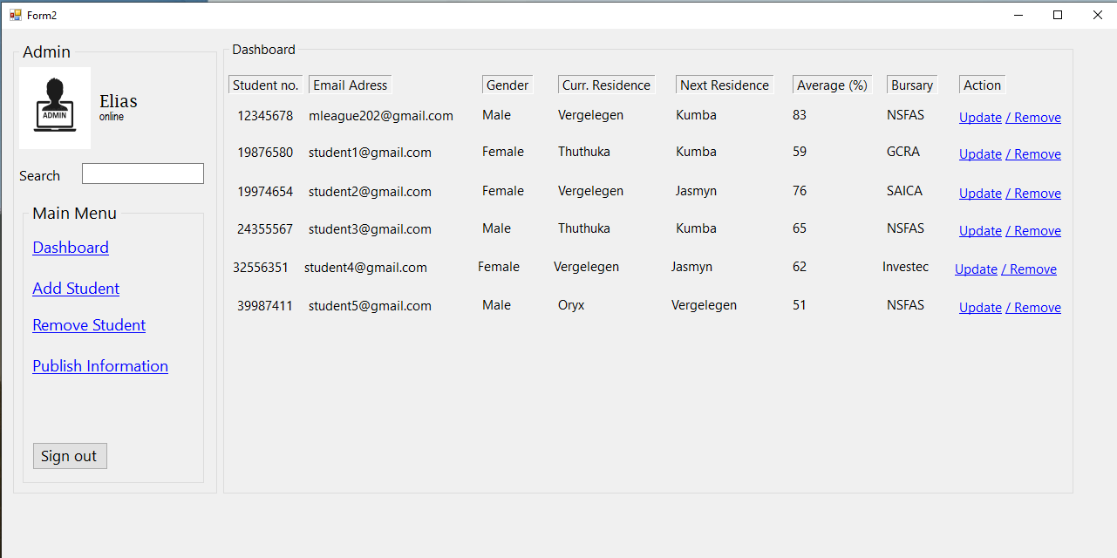

***Figure 4: Example of Admin Page (2)***

**ROOM SELECTION:**

* Display student’s information and whether they qualify for a single room or double.
* Floor plan to show students where rooms are situated in the unit to avoid confusion. For example, in the current system, students select G03 or 103 thinking it’s a room when it’s the bathroom.
* **Diagram

  Description automatically generated**After room selection the student will receive an email from the university with their reference number.

***Figure 5: Example of Room Selection Page***

**2.3 Non-functional Requirements**

Our system should meet the following non-functional requirements:

* Automatic log out if they forgot to log out for or does not use the system for x minutes.
* Authentication to verify if the credentials.
* Having ability to accommodate high volume of users.
* Number of students that the database can hold be 10000 or less.
* Boost website performance by caching static files on servers near to the users' locations.
* Web interface with only two tiers of access.
* Permissions combined into roles.
* Responsive for most devices for better experience.
* Web based help support that describes how to use the site.

*More non-functional requirements in detail:*

**Security**

Transaction data must be encrypted before and after being transmitted.

The user will be logged out automatically if they forgot to log out or no using the web app.

The web will have an authentication to verify if the credentials from E-Fundi are his/hers.

Cookies will be allowed only on *ssl* and configure the cookies to be *http-only*. This ensures that cookies cannot be accessed by client-side script, which means that our session or type authentication token cannot be read on a browser.

**Safety**

If a large portion of the database suffers significant loss as a result of a systemic malfunction, such as a disk collapse, the recovery process recovers a previous copy of the database that was backed up to archival storage and reconstructs a more current state by reapplying or redoing the operations of committed transactions from the backed-up log, up to the time of failure.

**Performance**

The system should be able to accommodate many users at the same time.

The maximum number of students that the database can hold is 10000.

Boost website performance by caching static files on servers near to the users' locations. This allows the site to load faster and demand on your main servers is reduced.

Filter results if you are looking for something unique or want to process a certain type of data.

**Reliability**

At least x percent of the time, the machine must be fully operating.

The downtime after a breakdown shall not exceed x hours.

**Usability**

The system will be user-friendly so that technical and non-technical student and admin will be able to sue it without problems.

A user (student or admin) who knows what product s/he wants should be able to find and access the page in x seconds.

**Control**

Our starting point is a web interface with only two tiers of access: administrator, who has complete access to all app functions, and student, who only has access to non-administrator features.

Permissions will be combined into roles.

**Supportability**

The system will be optimized, scalable and view-supported for computers, laptops, tablets and for mobile to be responsive for most devices for better responsive experience for the user.

Internet Explorer 4.0 or later, Microsoft Edge, Netscape Navigator/Communicator 3.0 or later, Mozilla Firefox, Safari, and Google Chrome must be able to access the system website.

**Online user documentation and assistance**

The system must have a web page that describes how to use the site. This page can be personalized depending on the sites the user has access to.

**Interfaces**

The system will have interface with Microsoft SQL database system for students and their information, the newly acquired language translation software, a developed website search engine and ASP.NET.

**2.4 Candidate System Matrix**

|  |  |  |  |
| --- | --- | --- | --- |
| **Characteristics** | **Candidate 1** | **Candidate 2** | **Candidate 3** |
| A brief description of the aspects of the cloud system. | Everything is sorted and made ready by the candidate. But the system won’t be fully functional yet. | The candidate will be able to solve the solution of the room allocation system problem and build an efficient and effective system except fixing the latency problem with the system. | A better System will be created to solve the res related problem by creating an efficient and effective room allocation system at res to give rooms to worthy deserving students according to their marks. |
| A brief Description of the University benefits that would be realized | N\A | The system will do its work with perfect precision in terms of allocating rooms to students. | The system will be created to solve the needs of the res allocation system to make it the best in terms of efficiency, prevention of corruption, elimination of too much paperwork as well as achieve better communication in terms of letting students know of their selection process if it was successful or not. |
| A description of the software needed to support the candidate’s functions as well as capabilities. | N\A | The server will use Linux. The primary software in the system will be the operating system consisting of IOS as well as windows. | Microsoft access as well as excess will be available towards assisting in supporting the candidates’ databases in terms of sorting out student’s data on the res system. |
| A description of the servers and workstations needed to support the candidate. | N\A | As the servers use Linux the workstations can include Microsoft windows as well as Mac IOS to run the system on entry level computers. | A computer is required to run the system as well as digital devices to alert the students of their res application in terms of their allocation. |
| Software tools needed to design and build the candidate not generally applicable if applications software packages are to be purchased. | N\A | N\A | This candidate will be programmed using C# as the main language with visual studio 2019.  The databases will be created using Microsoft access.  The candidate will be compatible with Microsoft windows as well as Mac IOS |
| Method of data-processing | Online google forms are issued for students to apply for res, and the application is processed and the information as well on the database and the allocation process begins. | All data is processed in real time on a server. | All data will be processed in real time on the computers. If a server is used the server’s database will also be required to be updated when needed. |
| Application Software.  A description of the software to be purchased, built or even accessed. | N\A | This candidate system is a system that is to be used by the school res allocation department by analysing data that the students sent by applying for res and according to their relevant marks allocating them a res and a room according to the criteria of the students results.  It is also open for adjustments from other developers as for students that don’t qualify they will be placed on the waiting list according to their average as well the one that fairs well in terms of average will be the one at the top of the list. | The system will be compatible with IOS and windows it will also have the capability to retrieve data this prevents and occasion when student’s applications get lost everything will now be on the system. |
| Output devices and implications. | N\A | The output will be a result of the chosen student’s names as well as student numbers per school res to be displayed on the computer. Before sending the news to the students to notify them of their selection. | The outputs of the application process will be visible on the school’s computers in the res department first then a message will be sent to students via email/SMS to notify them of their applications and their room selection and the email or SMS can be used as proof to claim the room key of a particular res. If one desires, they can print the whole thing out. |
| Input Devices and implications. | N\A | A computer as well as Microsoft access is required for the efficient running of the entire procedure. | A computer as well as Microsoft access is required for the efficient running of the entire procedure. |
| Storage Devices and implications. | The data which is the student’s applications is stored in files and has a backup file in the cloud. | All the candidates’ storage requirements are met with the help of the server.  The server is essential the workstation computer can be used as a server.  Cloud storage also plays a very critical part in the storage department in case data gets lost. | The candidates’ databases can be stored on computers hard-drive or even on a central server.  The system in terms of storage is very versatile |
| Output Software  The software needed by the system to display certain forms of output from the system. | N\A | The candidate is independent of external output applications. | The candidate produces most of its own output which are readable in many platforms, adobe in pdf format, Microsoft excess, word etc. |

**2.5 Feasibility Analysis Matrix**

|  |  |  |  |  |
| --- | --- | --- | --- | --- |
| **Description** | **Weights** | **Candidate 1 AS-IS** | **Candidate 2** | **Candidate 3** |
| Technical feasibility | 20 | The candidate can be used but cannot be changed by anyone in the team.  Score:0 | It wouldn’t be a problem to install this part but the maintenance part of it could be a problem.  Score:60 | As for this candidate will be programmed efficiently by the team with programming languages well known to the team. The team members have all the required knowledge to build the system  Score:30 |
| Operational Feasibility | 10 | The system that is currently fully functional at the school will serve is purpose of allocating students their rooms, but it is still glitches when analyzing the marks.  This candidate is efficient and cannot be fully trusted.  Score: 15 | This candidate will fulfil most of the requirements except of the process of alerting the students of their allocated rooms.  The candidate will make everything easier and efficient, but it will take time and understanding to fully understand it.  Score: 75 | This candidate will work efficiently by performing everything that’s required of it in the most effective way.  Similar to candidate 2 it will make everything easier and efficient.  The system will be designed as well as created to have a highly user-friendly interface it will be convenient for users to use the interface and not come with a lot of hassles. A user’s manual will also be added and provided with the systems delivery technical services will also be provided.  Score: 90 |
| Risk Feasibility | 10 | The system uses data as a means of operation as it could be hacked and stolen if the cyber security bar is not high on this system.  Score: 5 | It is possible that the implementation of the project will fail because of the technologies used.  Score: 10 | The project team is highly experienced and knowledgeable boasting some of the greatest minds in the ICT industry. This gives the project a very high rate of succeeding.  Score: 95 |
| Economic Feasibility  The cost to develop:  Payback Period:  Net Present value: | 25  Score:100% | N\A:  N\A:  N\A: | +/- 50250  Unknown as the system will be a lifetime program  N\A | +/-101750  Unknown as the system will be a lifetime program  N\A |
| Schedule Feasibility |  | In the case where this candidate shall be chosen everything will stay the same.  Score: 20 | The required hardware is not assembled in time and the team is not familiar with the languages as well as the software that will be used to code the project, in this case more time will be needed to complete the entire system, more like an additional one and a half month is needed to complete the project.  Score: 50 | Every part of the system must be designed and coded with perfection interface by interface starting everything from the bottom by means of reverse scheduling the system will be completed on time  Score:60 |
| Cultural Feasibility |  | Users are bound to show resistance to this system. | The user of the system may show a little bit interest but may still have a considerate amount of resistance towards the system. | The user’s resistance towards this candidate will be very minimal because the system will serve the needs of the students and do what is was created to do allocating rooms to well deserving students according to their marks. |
| Legal Feasibility | 20 | No legal problems associated with this candidate  Score: 100 | No legal problems  Score:100 | No legal problems  Score:100 |
| Weighted Feasibility | 100% |  |  |  |

**2.6 USE CASE GLOSSARY**

|  |  |  |
| --- | --- | --- |
| **Use Case Name** | **Use Case Description** | **Participating Applicants and Roles** |
| Log into system | Event where the user get access to the system using the student number and password as well as the Residence Administrators number and password. | Students  Residence-  Administrators |
| View  Details | This an event that will enable viewing of the Details | Residence-Administrators |
| Select  Room | This an event which will enable room selection and will be overseen by the Residence Administrator. | **Residence -Administrators**  Students |
| Submit  Appeal | This is an event where Students will be given a platform to be able to send an appeal on the system. | **Residence -Administrators**  Students |
| Edit  Application | This is an event with user case where Students will be given a platform to be able to edit their residence application on the system. | Students  **Residence -Administrators** |
| Cancel  Application | This use case describes an event where student will be able to cancel if they no longer interested in staying in that specific residence | Students  **Residence-**  **Administrators** |
| Process  Payment | This is an event where payment will be approved prior from Administrator on the system. | Administrator |
| Allocation  Room | This an event which will enable allocation of room and will be overseen by the Residence Administrator | Residence-  Administrator |
| Room  Deallocation | This an event which will disable allocation of room which was allocated to a student and will be overseen by the Residence Administrator | Residence-  Administrator |
| Backup data | This use case involves backing up of data that is on the system usually onto the external drive or google drive. | Administrators |
| Request report | This use case involves the event where a report is requested from the system and a hard copy of it can be printed. | Administrators |

**USE CASE DIAGRAM**

**2.7 INTERVIEW**

Interviewee: **Linda Du Preez** - system owner and principal of North west University VTC campus. **Karin Venter**- Administrator at (NWU-VTC)

Location North West University Vaal Triangle Campus (NWU-VTC)

Time: 12H00

Date: 27 June 2020

Reason for interview: Gain user requirement and thorough defining of the problems faced by the residence system.

|  |  |  |
| --- | --- | --- |
| Time allocated | Interview Question/Action | User Respond |
| 2 min | The reason for this interview is to be able to know all the problem faced by the current Residence information system and to be able to understand what user requirements are needed from you |  |
| 4 min | Which system is currently implemented that enables application of residence, sorting, placement, and room allocation at Your university residences? | The university uses google form when students apply. Then manual sorting of accepted applicants using spreadsheet. Students then needs to show up on a particular day of room selection to choose the room of their choice on paper (paper system). |
| 6 min | What are the flows with the current Residence management system that you wish for us to improve with newly anticipated residence system? | The Residence management system is more manual than automated, it takes a long time and a lot of effort. Almost everything is done manually, which has resulted in several of the problems. So, we need the system to be more of an automated system than manual starting with Application for residence, Sorting of averages, placements of students in different residences and helps with room placements to avoid occurring of duplication and have a floor plan. |
| 4 min | If we succeed with developing a system that meets your user requirements will you be willing to pay a fee in maintaining the system for you? A full detailed budget can be provided if you need it. | As long as the system is able to system will fulfils all the systems requirements in the given time I don’t see why we will not be willing to pay in order to keep the system maintained that is if it is reasonable and most affordable. |

**2.8 QUESTIONNAIRE**

Rate the following Residence system (FROM LOWEST [1] TO HIGHEST [5])

1. Is the current Residence application process, sorting of accepted students and placement system user-friendly?
   * 1
   * **2**
   * 3
   * 4
   * 5
2. How reliable is the current Residence system?

* 1
* **2**
* 3
* 4
* 5

1. Does the current Residence system make your job much easier (It requires for more manual work)?

* Yes
* **No, it is more manual t makes job more difficult**

What improvements are needed on the current system?

_________________________________________________________________________________________________________________________________________________________________________________________________________

1. Which area in the current Residence system needs to be improved

* User-friendly
* Responsiveness
* Reliability
* Database
* Placement
* **Room selection7 It’s the most challenging it needs to be improved**
* Others

______________________________________________________________________________________________________________________________________

1. What would you rate the quality based of the Current Residence system?

* 1
* **2**
* 3
* 4
* 5

1. Do you think implementing an entirely new Residence system is the best solution?

* **Yes**
* No

1. Is it easy for the students when they apply for residence with the current system (are they able to see pictures ”System supports pictures” of different residence even when they haven’t been to that particular residence, are they able to pick the best room)?

* Yes
* **No**

_____________________________________________________________________________________________________________________________________

**University Residence Research**

A questionnaire with a summary of findings

A couple of students were asked to complete a questionnaire.

1. How do you select a room where you are placed?

Answer: Count:

Stand in line 20

Any other way 0

Most of student must stand in line when they make room selection thus with the recent outbreak of Covid-19 pandemic it is a disadvantage.

1. Is the always challenges with choosing rooms?

Answer: Count:

Yes 13

No 4

Not sure 3

Most of the people experience problems when they must make room selection and thus causes a confusion as most people end up going to private accommodation

1. What method of recording room selection is used?

Answer: Count:

Manual writing in a paper 18

Any other Method used 2

During room selection they use manual recording, which is the one with many complications, so this is one of the reasons there is a need for an automated system.

**2.9 Summary, Future & Further Planning (PERT & Gantt chart)**

Covered in the document is the requirements for the Residence Administrative Management System (RAMS) for NWU-VTC. The requirements include timeline projection amongst other requirements analysis, timeline projection and system requirements. After the approval of the problem and requirements phase the next phase is the program design phase which will be our next step in build this system. Our phase will commence on the 29/04/2021 and is projected to end on the 19/05/2021.

**PERT Chart**

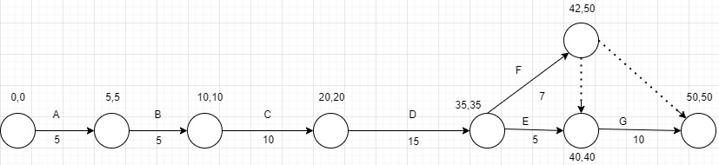

**Gantt Chart**

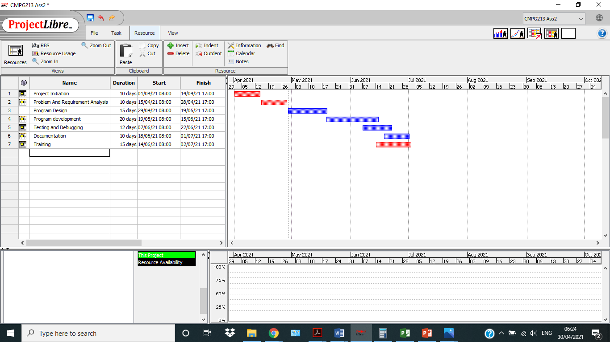

***Requirements Analysis Document***

**3.1 USE CASE DIAGRAM**

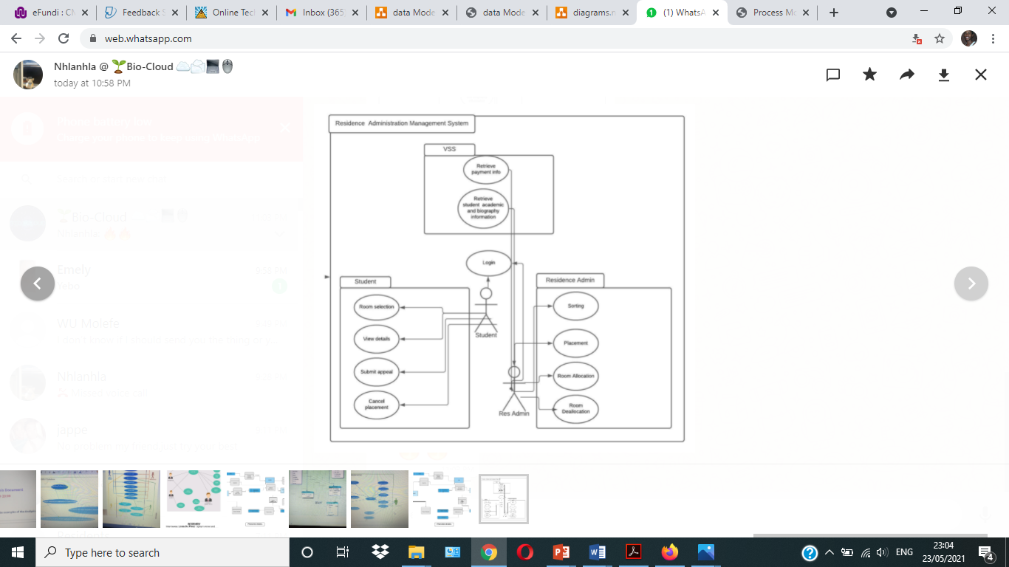

**3.2 DATA MODEL**

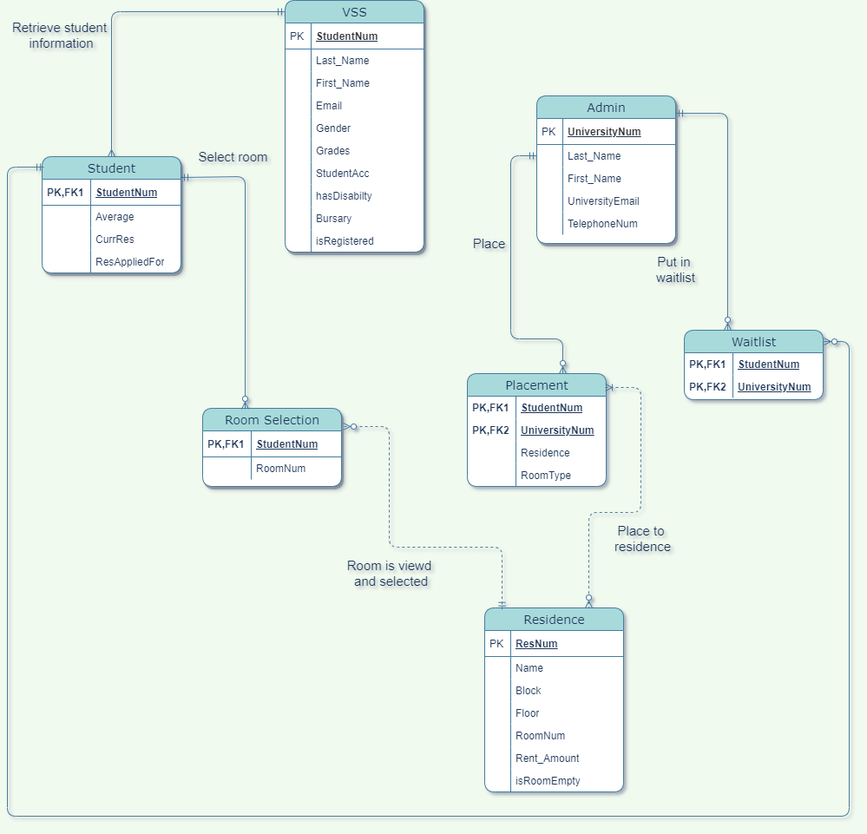

**3.3 Process Model**

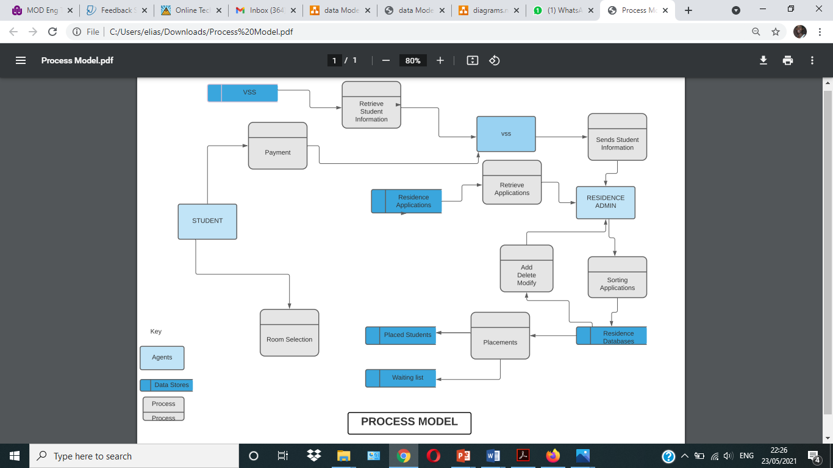

***Team Players***

1. **Project Manager:**

**Molefe Sentsho 29969263**



I will serve as the project manager for this project, ensuring the proper planning, organizing and the direction towards the completion of the project for the organization also ensuring projects are delivered on time on budget and within the scope.

1. **System Analyst:**

**Elias Setlatjile 36743615**



My capacity will be that of a systems analyst. I will be working hard to elucidate the owner's specifications to the team to best get precise comprehension. The team will be reliant on me to deliver the product of the highest quality and functionality through my interpretation of the problems and come up with the best possible solution to the problems.

1. **System Designer:**

**Setjhaba Stonga 32676964**



As a system designer I am responsible for the architecture and design of the system. I work hand in hand with the system’s analyst to give me problems to fix and the programmer in the actual development of the system. One of my qualities are good communication skills, empathy skill and critical thinking skills. I have experience in programming languages like C++, C#, Python and Java, and I’m eager to learn other technologies if there is a need for them in the development of the system.

1. **System Builder:**

**Thabang Ngakane 26581299**



I am creative a person and has experience in various programming languages including Python, C#, C++, and Basic knowledge in Java. I am hard a worker and a very dedicated individual who is very eager to learn more.

My roles include designing and coding the GUI and in helping the system builder code the system. I am also very involved in the documentation of the system.

1. **System Programmer:**

**Nhlanhla Mlambo 34570888**



As the programmer, I am responsible for the development of specific computer programs that will meet the specifications. It includes writing the actual code that makes the system work. Some of my strong points include having good interpersonal skills meaning that I will be able to effectively communicate with my team members and any additional parties involved in the project and ensuring that they are all satisfied. I have experience in c programming and python. I am also responsible for finding better and cost-effective ways of building the system.